**Tables loaded with the Demo Data:**

**\*Note that the ExpireDate/PostDate/BidTime/Date might be different in these tables because different team members executed queries at different times.**

Person:

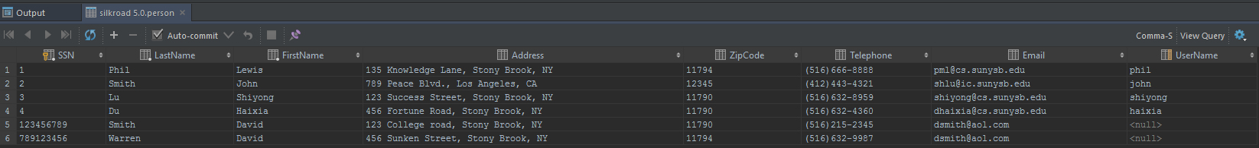

Customer:

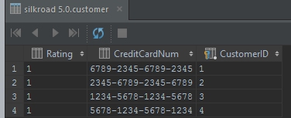

Employee:

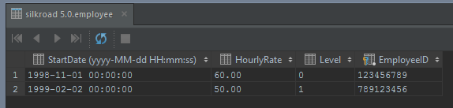

Item:

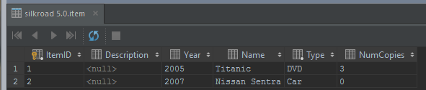

Auction:

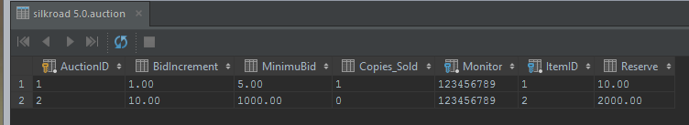

Post:

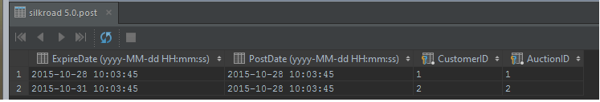

Bid:

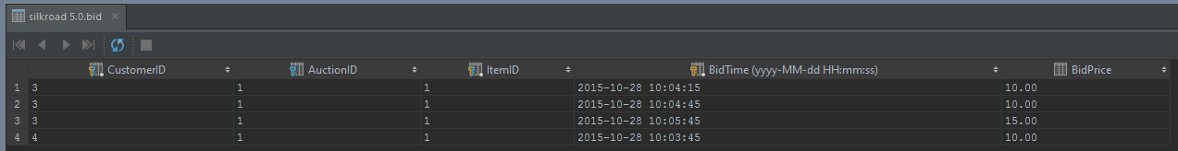

Sales:

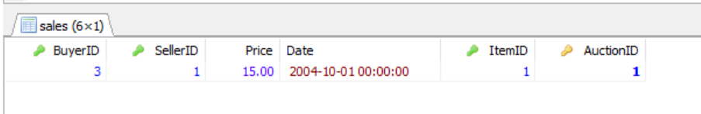

Full Dump:

-- MySQL dump 10.13 Distrib 5.6.27, for Win64 (x86_64)  
--  
-- Host: localhost Database: silkroad 5.0  
-- ------------------------------------------------------  
-- Server version 5.6.27-log  
  
/*!40101 **SET** @OLD_CHARACTER_SET_CLIENT=@@CHARACTER_SET_CLIENT */;  
/*!40101 **SET** @OLD_CHARACTER_SET_RESULTS=@@CHARACTER_SET_RESULTS */;  
/*!40101 **SET** @OLD_COLLATION_CONNECTION=@@COLLATION_CONNECTION */;  
/*!40101 **SET NAMES** utf8 */;  
/*!40103 **SET** @OLD_TIME_ZONE=@@TIME_ZONE */;  
/*!40103 **SET** TIME_ZONE=**'+00:00'** */;  
/*!40014 **SET** @OLD_UNIQUE_CHECKS=@@UNIQUE_CHECKS, UNIQUE_CHECKS=0 */;  
/*!40014 **SET** @OLD_FOREIGN_KEY_CHECKS=@@FOREIGN_KEY_CHECKS, FOREIGN_KEY_CHECKS=0 */;  
/*!40101 **SET** @OLD_SQL_MODE=@@SQL_MODE, SQL_MODE=**'NO_AUTO_VALUE_ON_ZERO'** */;  
/*!40111 **SET** @OLD_SQL_NOTES=@@SQL_NOTES, SQL_NOTES=0 */;  
  
--  
-- Table structure for table `auction`  
--  
  
**DROP TABLE IF EXISTS** `auction`;  
/*!40101 **SET** @saved_cs_client = @@character_set_client */;  
/*!40101 **SET** character_set_client = utf8 */;  
**CREATE TABLE** `auction` (  
 **`AuctionID` int**(10) **unsigned NOT NULL DEFAULT '0'**,  
 **`BidIncrement` decimal**(13,2) **DEFAULT NULL**,  
 **`MinimuBid` decimal**(13,2) **DEFAULT NULL**,  
 **`Copies_Sold` int**(10) **unsigned DEFAULT NULL**,  
 **`Monitor` int**(10) **unsigned NOT NULL**,  
 **`ItemID` int**(10) **unsigned NOT NULL**,  
 **`Reserve` decimal**(13,2) **DEFAULT NULL**,  
 **PRIMARY KEY** (**`AuctionID`**),  
 **KEY** `Monitor` (**`Monitor`**),  
 **KEY** `ItemID` (**`ItemID`**),  
 **CONSTRAINT** `auction_ibfk_1` **FOREIGN KEY** (**`Monitor`**) **REFERENCES** `employee` (**`EmployeeID`**) **ON DELETE NO ACTION ON UPDATE CASCADE**,  
 **CONSTRAINT** `auction_ibfk_2` **FOREIGN KEY** (**`ItemID`**) **REFERENCES** `item` (**`ItemID`**) **ON DELETE NO ACTION ON UPDATE CASCADE**) **ENGINE**=InnoDB **DEFAULT CHARSET**=utf8;  
/*!40101 **SET** character_set_client = @saved_cs_client */;  
  
--  
-- Dumping data for table `auction`  
--  
  
**LOCK TABLES** `auction` **WRITE**;  
/*!40000 **ALTER TABLE** `auction` **DISABLE KEYS** */;  
**INSERT INTO** `auction` **VALUES** (1,1.00,5.00,1,123456789,1,10.00),(2,10.00,1000.00,0,123456789,2,2000.00);  
/*!40000 **ALTER TABLE** `auction` **ENABLE KEYS** */;  
**UNLOCK TABLES**;  
  
--  
-- Table structure for table `bid`  
--  
  
**DROP TABLE IF EXISTS** `bid`;  
/*!40101 **SET** @saved_cs_client = @@character_set_client */;  
/*!40101 **SET** character_set_client = utf8 */;  
**CREATE TABLE** `bid` (  
 **`CustomerID` int**(10) **unsigned NOT NULL DEFAULT '0'**,  
 **`AuctionID` int**(10) **unsigned DEFAULT NULL**,  
 **`ItemID` int**(10) **unsigned NOT NULL DEFAULT '0'**,  
 **`BidTime` datetime NOT NULL DEFAULT '0000-00-00 00:00:00'**,  
 **`BidPrice` decimal**(13,2) **DEFAULT NULL**,  
 **PRIMARY KEY** (**`CustomerID`**,**`ItemID`**,**`BidTime`**),  
 **KEY** `ItemID` (**`ItemID`**),  
 **KEY** `AuctionID` (**`AuctionID`**),  
 **CONSTRAINT** `bid_ibfk_1` **FOREIGN KEY** (**`ItemID`**) **REFERENCES** `item` (**`ItemID`**) **ON DELETE NO ACTION ON UPDATE CASCADE**,  
 **CONSTRAINT** `bid_ibfk_2` **FOREIGN KEY** (**`CustomerID`**) **REFERENCES** `customer` (**`CustomerID`**) **ON DELETE NO ACTION ON UPDATE CASCADE**,  
 **CONSTRAINT** `bid_ibfk_3` **FOREIGN KEY** (**`AuctionID`**) **REFERENCES** `auction` (**`AuctionID`**) **ON DELETE NO ACTION ON UPDATE CASCADE**) **ENGINE**=InnoDB **DEFAULT CHARSET**=utf8;  
/*!40101 **SET** character_set_client = @saved_cs_client */;  
  
--  
-- Dumping data for table `bid`  
--  
  
**LOCK TABLES** `bid` **WRITE**;  
/*!40000 **ALTER TABLE** `bid` **DISABLE KEYS** */;  
**INSERT INTO** `bid` **VALUES** (3,1,1,**'2015-10-28 14:07:07'**,10.00),(3,1,1,**'2015-10-28 14:07:37'**,10.00),(3,1,1,**'2015-10-28 14:08:37'**,15.00),(4,1,1,**'2015-10-28 14:06:37'**,10.00);  
/*!40000 **ALTER TABLE** `bid` **ENABLE KEYS** */;  
**UNLOCK TABLES**;  
  
--  
-- Table structure for table `customer`  
--  
  
**DROP TABLE IF EXISTS** `customer`;  
/*!40101 **SET** @saved_cs_client = @@character_set_client */;  
/*!40101 **SET** character_set_client = utf8 */;  
**CREATE TABLE** `customer` (  
 **`Rating` int**(10) **unsigned DEFAULT '1'**,  
 **`CreditCardNum` char**(19) **DEFAULT NULL**,  
 **`CustomerID` int**(10) **unsigned NOT NULL DEFAULT '0'**,  
 **PRIMARY KEY** (**`CustomerID`**),  
 **CONSTRAINT** `customer_ibfk_1` **FOREIGN KEY** (**`CustomerID`**) **REFERENCES** `person` (**`SSN`**) **ON DELETE NO ACTION ON UPDATE CASCADE**) **ENGINE**=InnoDB **DEFAULT CHARSET**=utf8;  
/*!40101 **SET** character_set_client = @saved_cs_client */;  
  
--  
-- Dumping data for table `customer`  
--  
  
**LOCK TABLES** `customer` **WRITE**;  
/*!40000 **ALTER TABLE** `customer` **DISABLE KEYS** */;  
**INSERT INTO** `customer` **VALUES** (1,**'6789-2345-6789-2345'**,1),(1,**'2345-6789-2345-6789'**,2),(1,**'1234-5678-1234-5678'**,3),(1,**'5678-1234-5678-1234'**,4);  
/*!40000 **ALTER TABLE** `customer` **ENABLE KEYS** */;  
**UNLOCK TABLES**;  
  
--  
-- Table structure for table `employee`  
--  
  
**DROP TABLE IF EXISTS** `employee`;  
/*!40101 **SET** @saved_cs_client = @@character_set_client */;  
/*!40101 **SET** character_set_client = utf8 */;  
**CREATE TABLE** `employee` (  
 **`StartDate` datetime DEFAULT NULL**,  
 **`HourlyRate` decimal**(5,2) **unsigned DEFAULT NULL**,  
 **`Level` int**(10) **unsigned DEFAULT '0'**,  
 **`EmployeeID` int**(10) **unsigned NOT NULL DEFAULT '0'**,  
 **PRIMARY KEY** (**`EmployeeID`**),  
 **CONSTRAINT** `employee_ibfk_1` **FOREIGN KEY** (**`EmployeeID`**) **REFERENCES** `person` (**`SSN`**) **ON DELETE NO ACTION ON UPDATE CASCADE**) **ENGINE**=InnoDB **DEFAULT CHARSET**=utf8;  
/*!40101 **SET** character_set_client = @saved_cs_client */;  
  
--  
-- Dumping data for table `employee`  
--  
  
**LOCK TABLES** `employee` **WRITE**;  
/*!40000 **ALTER TABLE** `employee` **DISABLE KEYS** */;  
**INSERT INTO** `employee` **VALUES** (**'1998-11-01 00:00:00'**,60.00,0,123456789),(**'1999-02-02 00:00:00'**,50.00,1,789123456);  
/*!40000 **ALTER TABLE** `employee` **ENABLE KEYS** */;  
**UNLOCK TABLES**;  
  
--  
-- Table structure for table `item`  
--  
  
**DROP TABLE IF EXISTS** `item`;  
/*!40101 **SET** @saved_cs_client = @@character_set_client */;  
/*!40101 **SET** character_set_client = utf8 */;  
**CREATE TABLE** `item` (  
 **`ItemID` int**(10) **unsigned NOT NULL DEFAULT '0'**,  
 **`Description` varchar**(255) **DEFAULT NULL**,  
 **`Year` year**(4) **DEFAULT NULL**,  
 **`Name` char**(255) **DEFAULT NULL**,  
 **`Type` enum**(**'DVD'**,**'Car'**,**'Clothing'**,**'Video Game'**,**'Electronic'**,**'Miscellaneous'**,**'Book'**,**'Laptop'**) **NOT NULL**,  
 **`NumCopies` int**(10) **unsigned DEFAULT NULL**,  
 **PRIMARY KEY** (**`ItemID`**)  
) **ENGINE**=InnoDB **DEFAULT CHARSET**=utf8;  
/*!40101 **SET** character_set_client = @saved_cs_client */;  
  
--  
-- Dumping data for table `item`  
--  
  
**LOCK TABLES** `item` **WRITE**;  
/*!40000 **ALTER TABLE** `item` **DISABLE KEYS** */;  
**INSERT INTO** `item` **VALUES** (1,**NULL**,2005,**'Titanic'**,**'DVD'**,3),(2,**NULL**,2007,**'Nissan Sentra'**,**'Car'**,0);  
/*!40000 **ALTER TABLE** `item` **ENABLE KEYS** */;  
**UNLOCK TABLES**;  
  
--  
-- Table structure for table `person`  
--  
  
**DROP TABLE IF EXISTS** `person`;  
/*!40101 **SET** @saved_cs_client = @@character_set_client */;  
/*!40101 **SET** character_set_client = utf8 */;  
**CREATE TABLE** `person` (  
 **`SSN` int**(10) **unsigned NOT NULL DEFAULT '0'**,  
 **`LastName` char**(20) **NOT NULL**,  
 **`FirstName` char**(20) **NOT NULL**,  
 **`Address` char**(255) **DEFAULT NULL**,  
 **`ZipCode` int**(10) **unsigned DEFAULT NULL**,  
 **`Telephone` char**(13) **DEFAULT NULL**,  
 **`Email` char**(25) **DEFAULT NULL**,  
 **`UserName` char**(20) **DEFAULT NULL**,  
 **PRIMARY KEY** (**`SSN`**),  
 **UNIQUE KEY** `UserName` (**`UserName`**)  
) **ENGINE**=InnoDB **DEFAULT CHARSET**=utf8;  
/*!40101 **SET** character_set_client = @saved_cs_client */;  
  
--  
-- Dumping data for table `person`  
--  
  
**LOCK TABLES** `person` **WRITE**;  
/*!40000 **ALTER TABLE** `person` **DISABLE KEYS** */;  
**INSERT INTO** `person` **VALUES** (1,**'Phil'**,**'Lewis'**,**'135 Knowledge Lane, Stony Brook, NY'**,11794,**'(516)666-8888'**,**'pml@cs.sunysb.edu'**,**'phil'**),(2,**'Smith'**,**'John'**,**'789 Peace Blvd., Los Angeles, CA'**,12345,**'(412)443-4321'**,**'shlu@ic.sunysb.edu'**,**'john'**),(3,**'Lu'**,**'Shiyong'**,**'123 Success Street, Stony Brook, NY'**,11790,**'(516)632-8959'**,**'shiyong@cs.sunysb.edu'**,**'shiyong'**),(4,**'Du'**,**'Haixia'**,**'456 Fortune Road, Stony Brook, NY'**,11790,**'(516)632-4360'**,**'dhaixia@cs.sunysb.edu'**,**NULL**),(123456789,**'Smith'**,**'David'**,**'123 College road, Stony Brook, NY'**,11790,**'(516)215-2345'**,**'dsmith@aol.com'**,**NULL**),(789123456,**'Warren'**,**'David'**,**'456 Sunken Street, Stony Brook, NY'**,11794,**'(516)632-9987'**,**'dsmith@aol.com'**,**NULL**);  
/*!40000 **ALTER TABLE** `person` **ENABLE KEYS** */;  
**UNLOCK TABLES**;  
  
--  
-- Table structure for table `post`  
--  
  
**DROP TABLE IF EXISTS** `post`;  
/*!40101 **SET** @saved_cs_client = @@character_set_client */;  
/*!40101 **SET** character_set_client = utf8 */;  
**CREATE TABLE** `post` (  
 **`ExpireDate` datetime DEFAULT NULL**,  
 **`PostDate` datetime DEFAULT NULL**,  
 **`CustomerID` int**(10) **unsigned NOT NULL**,  
 **`AuctionID` int**(10) **unsigned NOT NULL**,  
 **PRIMARY KEY** (**`CustomerID`**,**`AuctionID`**),  
 **KEY** `AuctionID` (**`AuctionID`**),  
 **CONSTRAINT** `post_ibfk_1` **FOREIGN KEY** (**`CustomerID`**) **REFERENCES** `customer` (**`CustomerID`**) **ON DELETE NO ACTION ON UPDATE CASCADE**,  
 **CONSTRAINT** `post_ibfk_2` **FOREIGN KEY** (**`AuctionID`**) **REFERENCES** `auction` (**`AuctionID`**) **ON DELETE NO ACTION ON UPDATE CASCADE**) **ENGINE**=InnoDB **DEFAULT CHARSET**=utf8;  
/*!40101 **SET** character_set_client = @saved_cs_client */;  
  
--  
-- Dumping data for table `post`  
--  
  
**LOCK TABLES** `post` **WRITE**;  
/*!40000 **ALTER TABLE** `post` **DISABLE KEYS** */;  
**INSERT INTO** `post` **VALUES** (**'2015-10-28 14:06:37'**,**'2015-10-28 14:06:37'**,1,1),(**'2015-10-31 14:06:37'**,**'2015-10-28 14:06:37'**,2,2);  
/*!40000 **ALTER TABLE** `post` **ENABLE KEYS** */;  
**UNLOCK TABLES**;  
  
--  
-- Table structure for table `sales`  
--  
  
**DROP TABLE IF EXISTS** `sales`;  
/*!40101 **SET** @saved_cs_client = @@character_set_client */;  
/*!40101 **SET** character_set_client = utf8 */;  
**CREATE TABLE** `sales` (  
 **`BuyerID` int**(10) **unsigned NOT NULL**,  
 **`SellerID` int**(10) **unsigned NOT NULL**,  
 **`Price` decimal**(13,2) **NOT NULL**,  
 **`Date` datetime NOT NULL**,  
 **`ItemID` int**(10) **unsigned NOT NULL**,  
 **`AuctionID` int**(10) **unsigned NOT NULL DEFAULT '0'**,  
 **PRIMARY KEY** (**`AuctionID`**),  
 **KEY** `BuyerID` (**`BuyerID`**),  
 **KEY** `SellerID` (**`SellerID`**),  
 **KEY** `ItemID` (**`ItemID`**),  
 **CONSTRAINT** `sales_ibfk_1` **FOREIGN KEY** (**`BuyerID`**) **REFERENCES** `customer` (**`CustomerID`**) **ON DELETE NO ACTION ON UPDATE CASCADE**,  
 **CONSTRAINT** `sales_ibfk_2` **FOREIGN KEY** (**`SellerID`**) **REFERENCES** `customer` (**`CustomerID`**) **ON DELETE NO ACTION ON UPDATE CASCADE**,  
 **CONSTRAINT** `sales_ibfk_3` **FOREIGN KEY** (**`AuctionID`**) **REFERENCES** `auction` (**`AuctionID`**) **ON DELETE NO ACTION ON UPDATE CASCADE**,  
 **CONSTRAINT** `sales_ibfk_4` **FOREIGN KEY** (**`ItemID`**) **REFERENCES** `item` (**`ItemID`**) **ON DELETE NO ACTION ON UPDATE CASCADE**) **ENGINE**=InnoDB **DEFAULT CHARSET**=utf8;  
/*!40101 **SET** character_set_client = @saved_cs_client */;  
  
--  
-- Dumping data for table `sales`  
--  
  
**LOCK TABLES** `sales` **WRITE**;  
/*!40000 **ALTER TABLE** `sales` **DISABLE KEYS** */;  
**INSERT INTO** `sales` **VALUES** (3,1,15.00,**'2015-10-28 14:06:37'**,1,1);  
/*!40000 **ALTER TABLE** `sales` **ENABLE KEYS** */;  
**UNLOCK TABLES**;  
/*!40103 **SET** TIME_ZONE=@OLD_TIME_ZONE */;  
  
/*!40101 **SET** SQL_MODE=@OLD_SQL_MODE */;  
/*!40014 **SET** FOREIGN_KEY_CHECKS=@OLD_FOREIGN_KEY_CHECKS */;  
/*!40014 **SET** UNIQUE_CHECKS=@OLD_UNIQUE_CHECKS */;  
/*!40101 **SET** CHARACTER_SET_CLIENT=@OLD_CHARACTER_SET_CLIENT */;  
/*!40101 **SET** CHARACTER_SET_RESULTS=@OLD_CHARACTER_SET_RESULTS */;  
/*!40101 **SET** COLLATION_CONNECTION=@OLD_COLLATION_CONNECTION */;  
/*!40111 **SET** SQL_NOTES=@OLD_SQL_NOTES */;  
  
-- Dump completed on 2015-10-28 14:21:04